**Simple Calculator Documentation**

This is a python program that implements a simple mathematical calculation with advanced features such as addition, subtraction, multiplication, division, exponentiation, and the option to quit. This document provides detailed explanations of the code, its main features, functionality, and usage instructions with images.

**Features**

* Addition
* Subtraction
* Multiplication
* Division
* Exponentiation
* Option to quit the program

**Code Explanation with Images**

* First Import math module

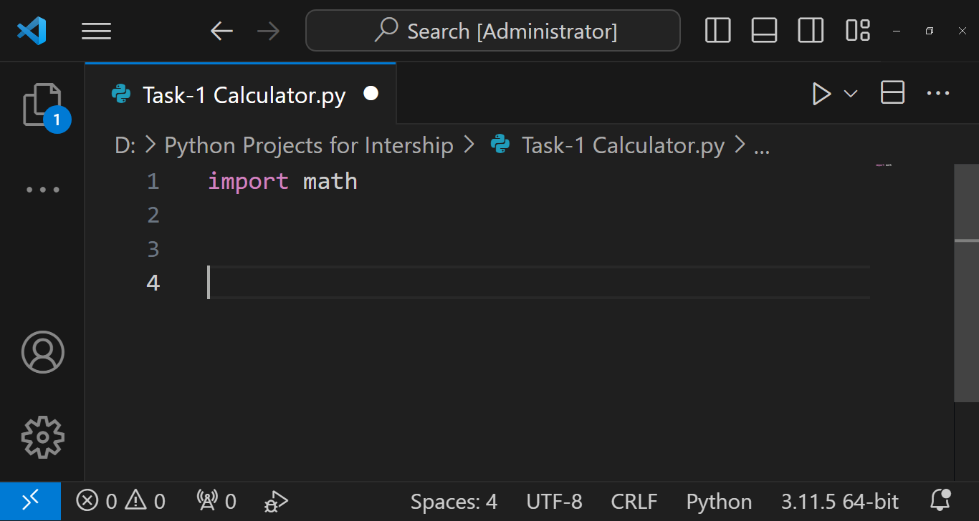

* Create functions for add(), subtract(), multiply(), divide(), and exponentiate() to implement basic arithmetic operations

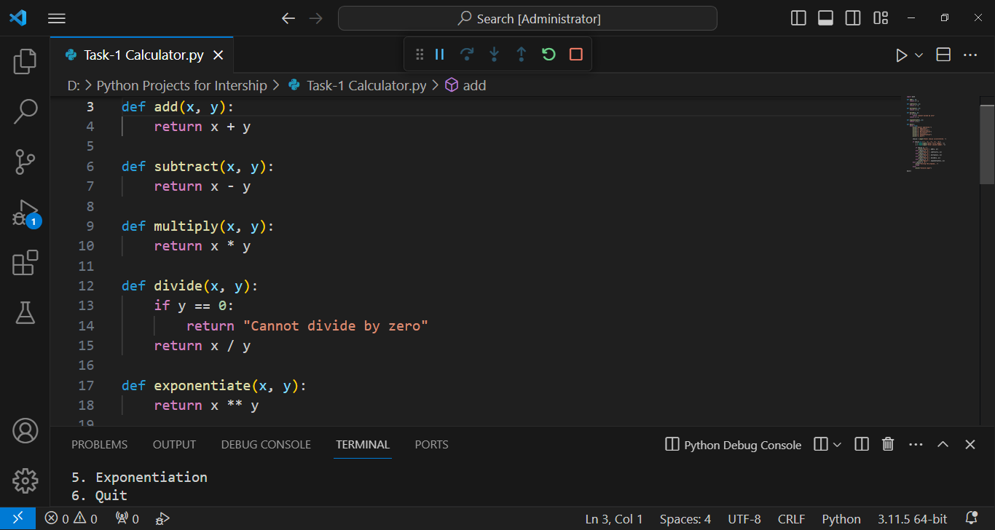

* Create main() function contains the main logic of the program including the user interface and input handling in While loop

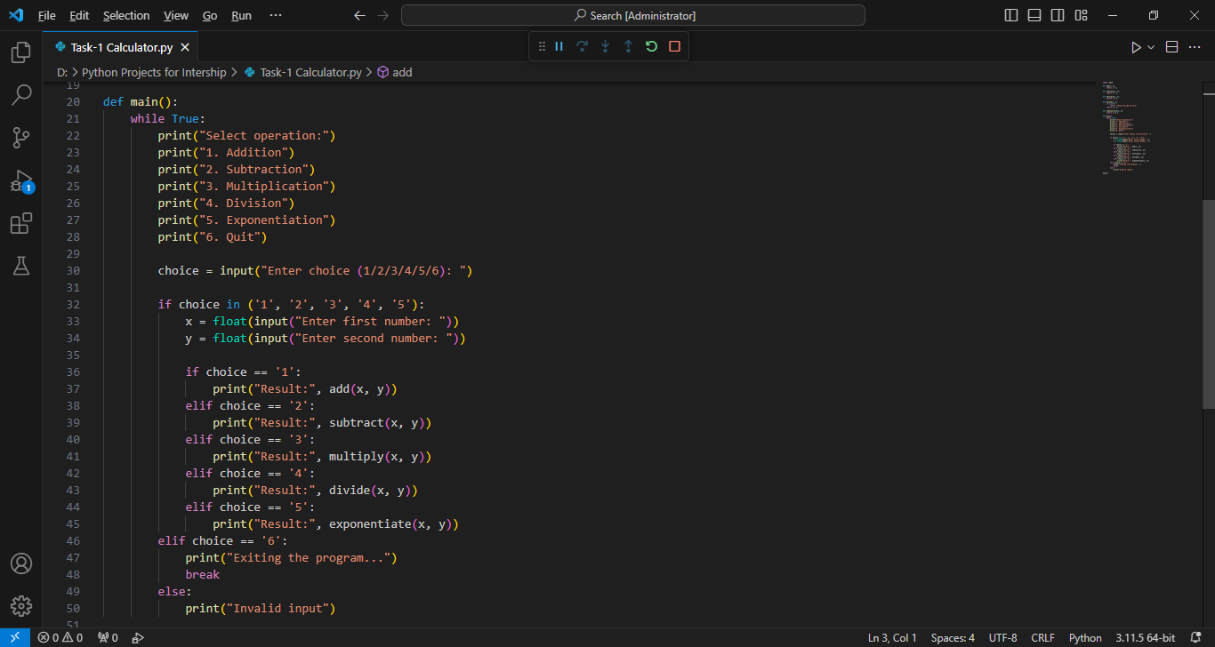

* Because of the While loop program continuously prompts the user to select an operation until the user chooses to quit
* This program also handling the error from invalid inputs and prevents division by zero
* Lastly, call the main() function

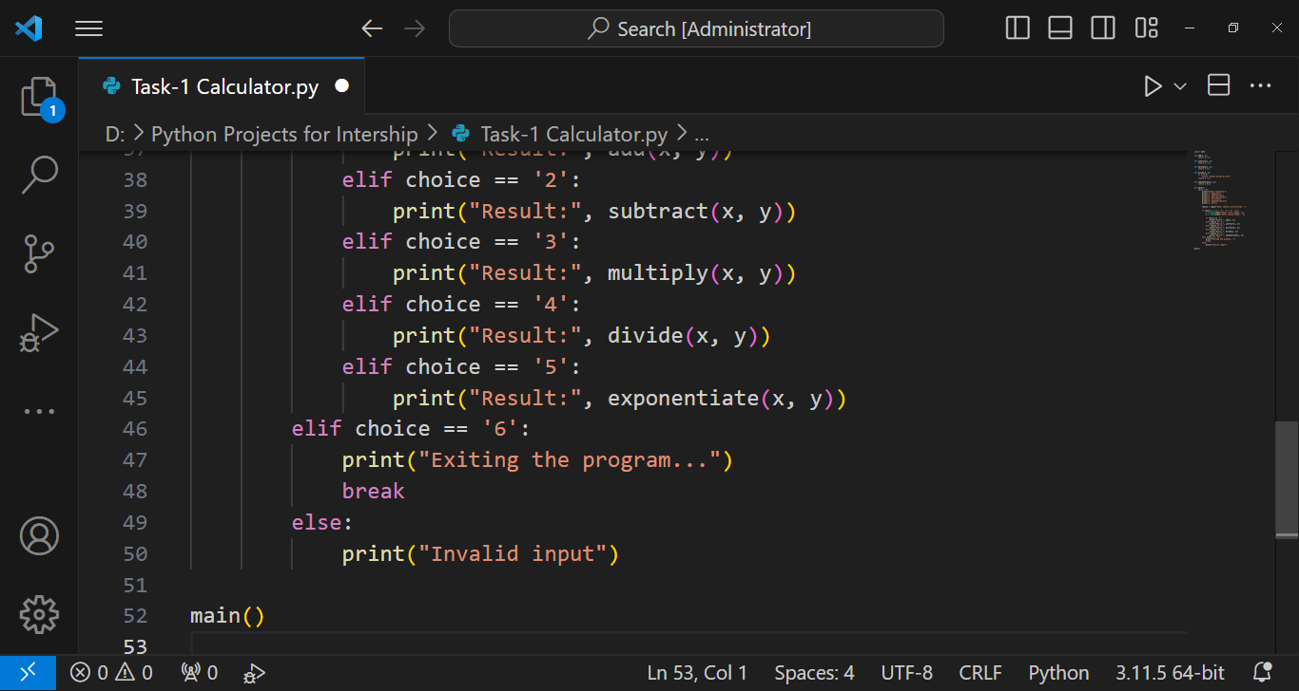

**Usage**

* Run this python script
* Follow the on-screen instructions to select an operation and enter numbers
* View the result displayed on the console
* To quit the program, select the "Quit" option
* Addition

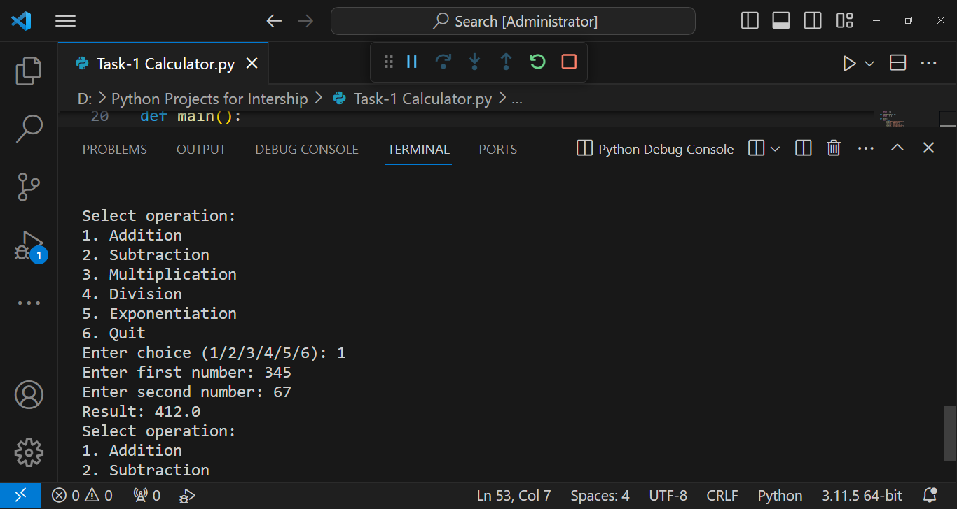

* Subtraction

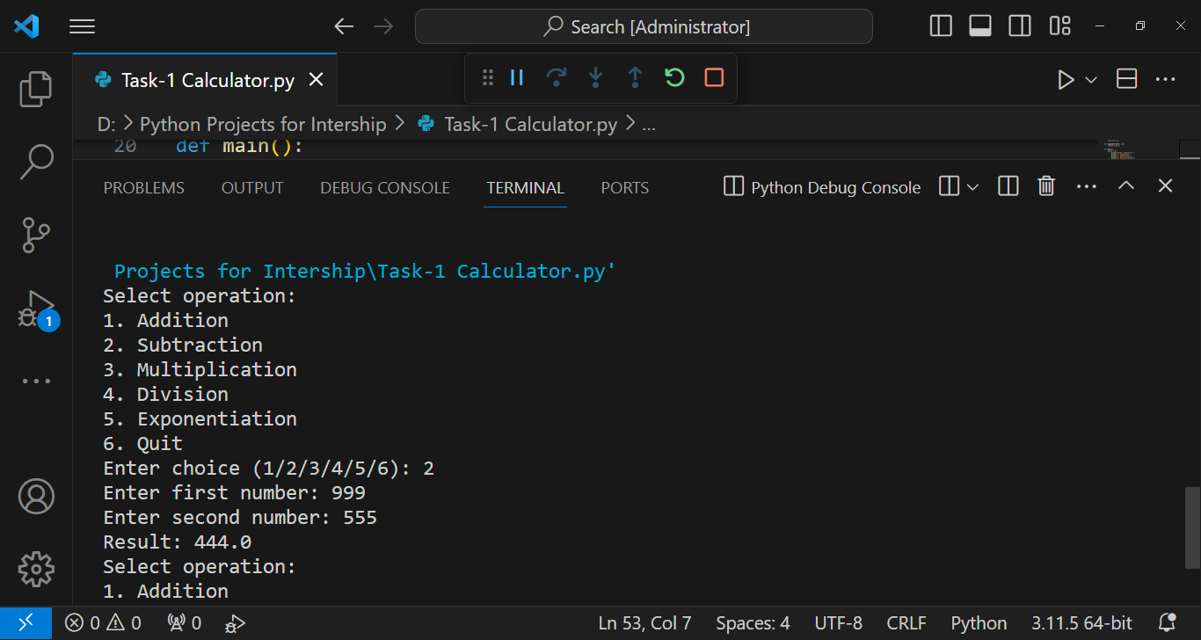

* Multiplication

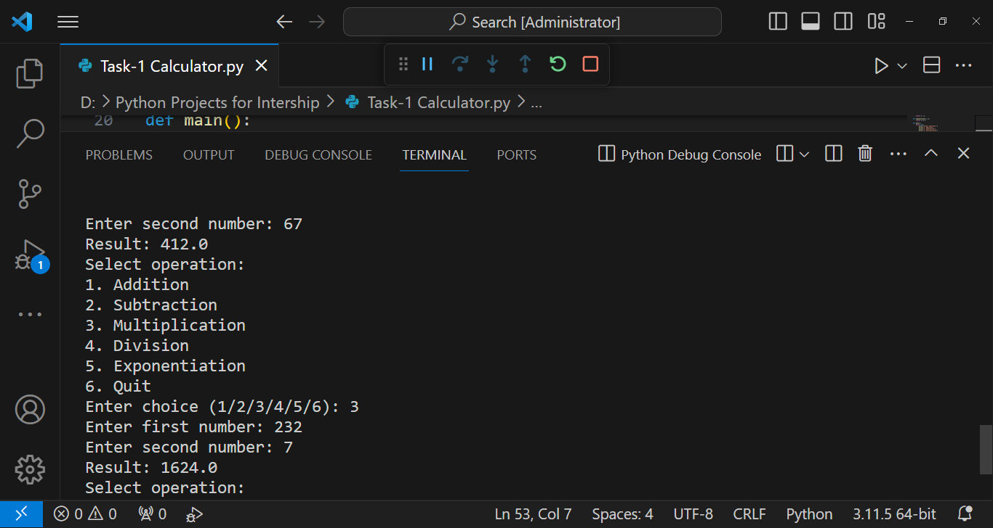

* Division

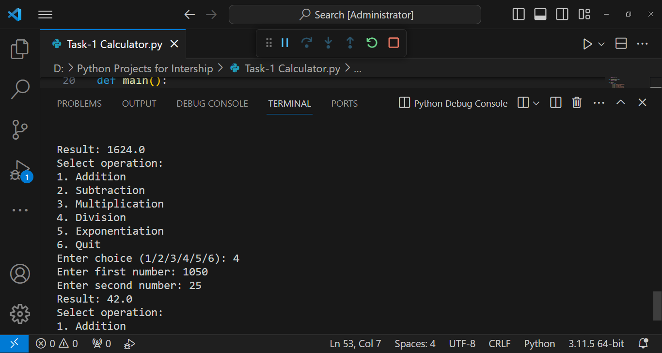

* When You perform division by zero

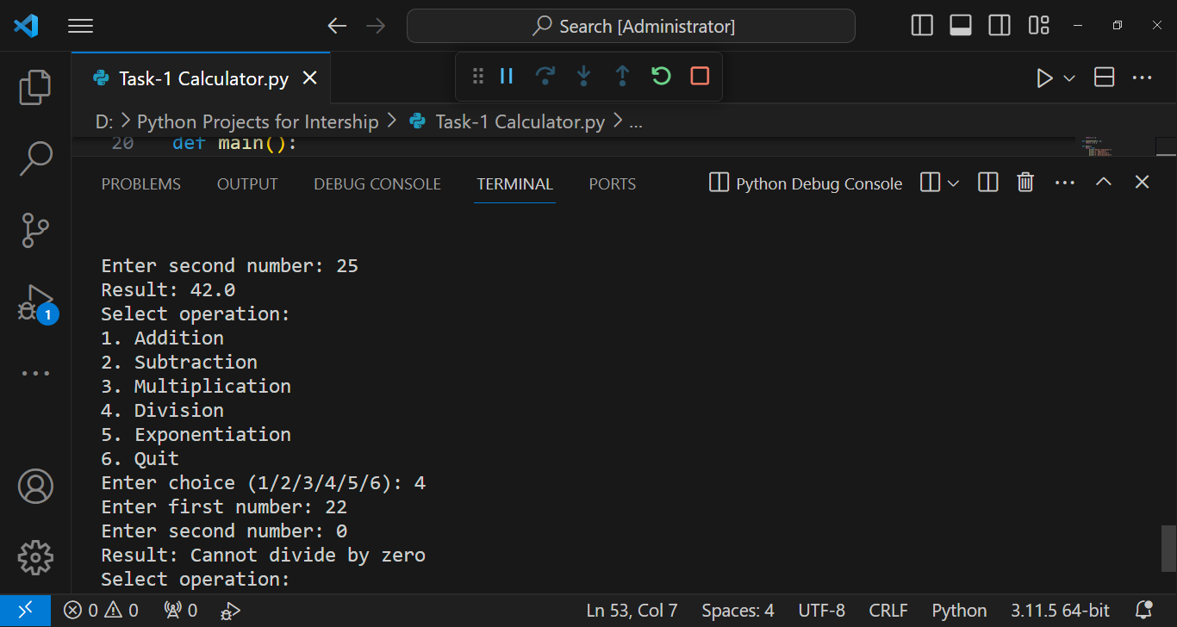

* Exponentiation

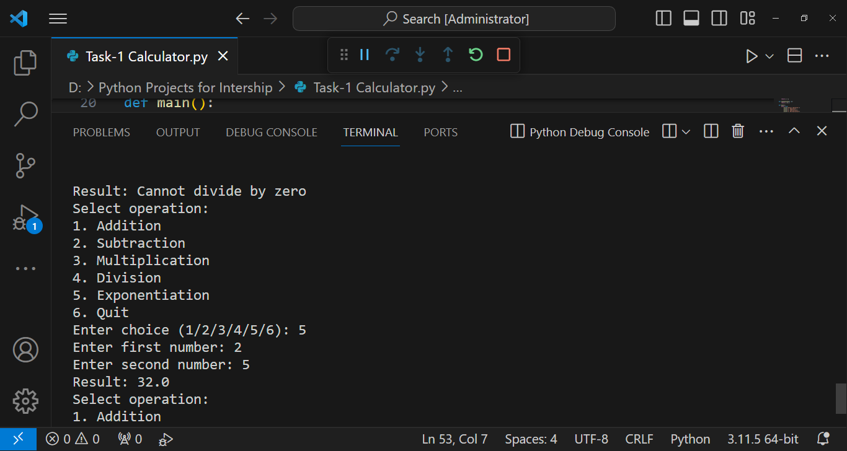

* Quit

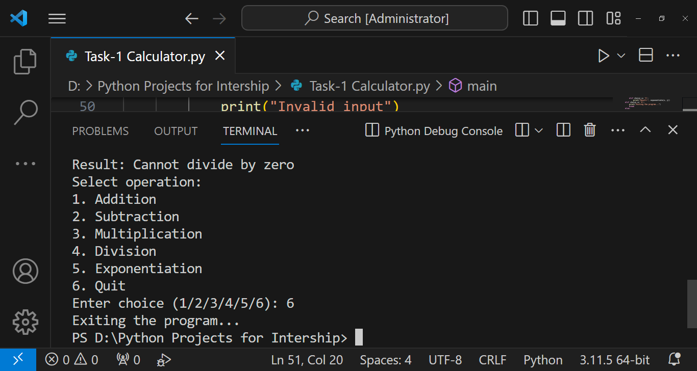

**Conclusion**

This python calculator program provides a simple and intuitive way to perform arithmetic calculations. With its user-friendly interface and basic arithmetic operations, it serves as a useful tool for performing calculations quickly and efficiently.